**life cycle of a case:**

The description below explains the life cycle of a case within Microsoft Dynamics CRM, from the initiating activity to the case resolution.

* When a customer initiates contact with your organization, it is saved as a communication activity, such as an e-mail message, phone call, or letter. These activities are either created automatically, such as an incoming e-mail message, or manually, such as a letter received.
* The activity is then sent to a queue to wait for someone to take ownership of the activity.  Alternatively, workflows could be developed to automatically acknowledge the customer communication and route the service  
  request to the appropriate individual or department in your organization.
* The new owner converts the activity to a case and starts working to resolve the customer's issue. The customer  
  service representative (CSR) can link the case to an existing account or contract and view historical information about the account or contact. If there is a contract, the case can be linked to a specific contract line that allows the allotment to be added to the billable total time. As the CSR researches the issue, the CSR can link to a relevant Knowledgebase article and forward to the customer as appropriate.
* Further contact with the customer and activities performed to close the case are also saved.
* When the case is resolved, it is removed from the queue automaticallly. The closed acivities, including the case resolution, can be viewed in the history of the account or contact. Customer Care dashboards and reports can give management insight into this important department of the company.

One of the most powerful features of MS Dynamics CRM is the [Customer Service Module](https://www.microsoft.com/en-us/dynamics/crm-customer-center/get-started-with-service-management.aspx) which allows us to manage and track customer service activities in an organization. The customer service functionality is broken down to two parts- Service Management and Service Scheduling. The Service Management is designed to support incident based services called Cases. The Case Entity provides incident based tracking for issues that may arise from customers, whether they are external or internal. A customer service representative creates an incident (case) to track a customer request, question or a problem. All actions and communications can be tracked in the incident entity. An incident can be in one of the three states Active, Resolved or Cancelled.

The Case Management is designed to track the process from the initial intake of an incident, tracking the details throughout the remedy process and through final resolution. MS Dynamics Cases are, most commonly used in help desk scenarios, in which a customer has an issue with a product or service; the activities to resolve the issue need to be tracked in an organized manner from when the issue was first reported to resolution of the issue.

In this post, we are trying to provide a step-by-step guidance on how to add a case, significance of automatic case creation, and creating rules.

**How to add a Case?**

Following are the steps to create a Case in Dynamics CRM: –

1.Using the top navigation bar in CRM select Service > Cases as shown in the following screen shot.

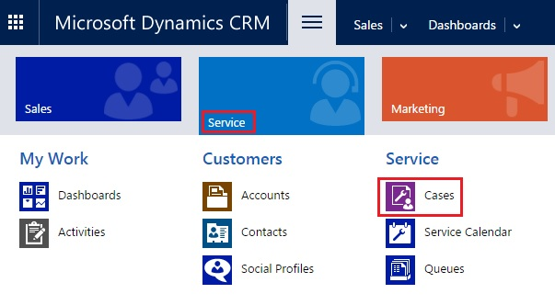

2. On the command bar click **New Case**.

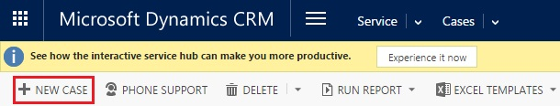

3. Fill out the necessary fields in the new Case form. The required fields on the form are **Title** (name of the Case), **Customer** (lookup to select the associated account in CRM).

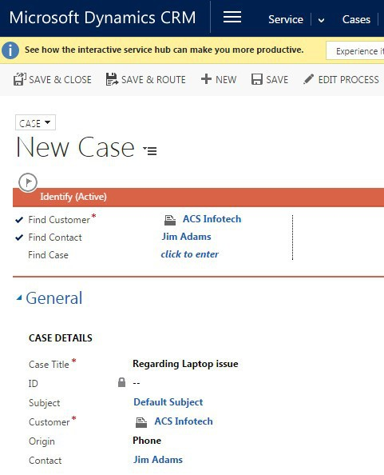  
**4. After filling the information click Save & Close.**

A new case is created and it will stay open, and it can be assigned to a user, team or added to a queue to be worked on. Once the case is created, activities can be tracked and linked back to the Case. If time is being tracked within the activities, CRM will roll up and total the time recorded in those activities so that the time can be used for reporting and analytical purposes. All the activities must be completed before the Case can be resolved.

**Automatic Case creation**

While working with cases in Microsoft Dynamics CRM, you might have to automatically create cases based on certain defined business rules and from multiple sources like email, chat, and so on.

This feature takes automation to even further level, where in Dynamics CRM out of the box provides Automatic case creation with some basic configuration steps.

A recent feature in MS Dynamics CRM, Automated Case Creation process enables to set rules that help to trigger new cases received by email.

Combined with routing rules Dynamics CRM provides functionality to create cases by avoiding the manual process of conversion of emails to cases.

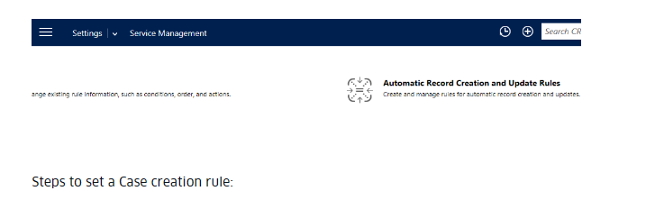

**Steps to set a Case creation rule:**

1. Go to Settings->Service Management->Automatic Record Creation and Update Rules.
2. From the command bar select new option
3. A window will pop up and there we can specify the source of case [example: email] and other details
4. In the next step we have to specify the conditions for case creation.
5. In the final step the rule should be activated.

So when an email comes based on the conditions of the rule, a Case will be created in CRM.

In the latest release for CRM 2016 update1, it supports creation of other entities apart from Case.

This gives higher flexibility to the administrator to write complex process, trigger multiple actions on the basis of different criteria.

Below are some screenshots to explain creation of rule and configuration of actions

**Create new Rule**

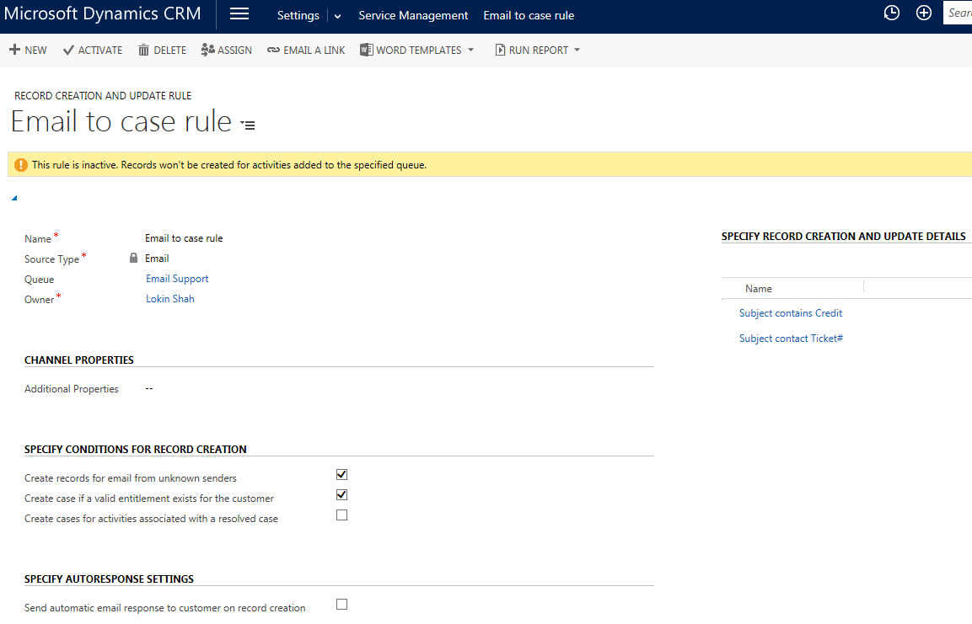

**Select criteria**

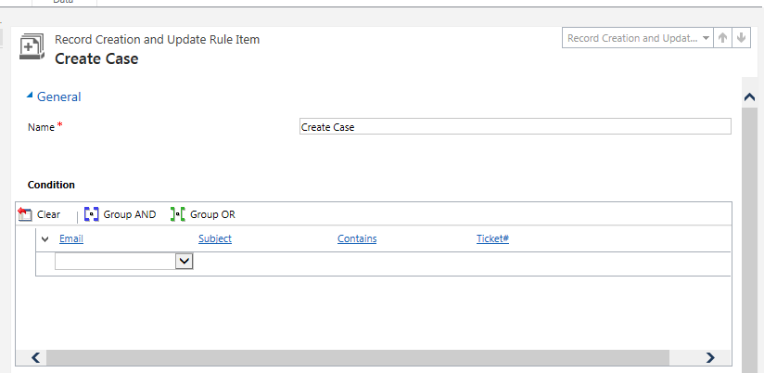

**Add multiple actions apart from case creation**

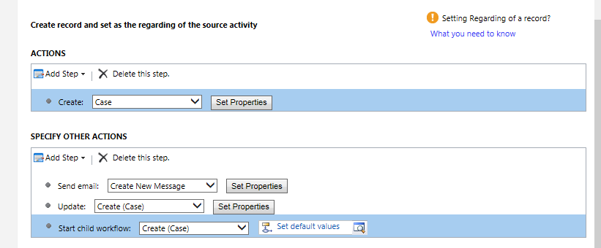

**Automatically create a case from an email (Customer Service):**

**https://www.microsoft.com/en-us/dynamics/crm-customer-center/automatically-create-a-case-from-an-email-customer-service.aspx**

Reduce the need for manually creating cases from incoming emails and increase the efficiency of customer service agents by creating automatic case creation rules in Microsoft Dynamics 365. The conditions in these rules automatically convert emails to support cases.

## https://www.microsoft.com/dynamics/crm/content/images/Help-Expand-Section-Microsoft-CRM.pngCreate cases automatically using rules

1. Make sure that you have the Customer Service Manager, System Administrator, or System Customizer security role or equivalent permissions.

When a case creation rule is activated, a corresponding workflow is created automatically. If you create or assign a rule, you must have permissions to perform the same action on workflows. The case creation rule is applied and a case is created in context to the permissions that the owner of the case creation rule has.

https://www.microsoft.com/dynamics/crm/content/images/Help-Chapter-Closed-Microsoft-CRM.pngCheck your security role

* + Follow the steps in [View your user profile](https://www.microsoft.com/en-us/dynamics/crm-customer-center/view-your-user-profile.aspx).
  + Don’t have the correct permissions? Contact your system administrator.

1. Go to **Settings**>**Service Management**.
2. Click **Automatic Case Creation Rules**.
3. To create a new case creation rule, click **New**.

-OR-

To edit an existing rule, in the list of rules, select a rule, and then on the command bar, click **Edit**.

1. Type or modify information in the fields.

Hover over the field labels to see what to enter.

* + **Name**. Type the name of the queue the rule is defined for.
  + **Source Type**. Select **Email** to indicate that cases will be created automatically from email messages.
  + **Queue**. Select the queue that the rule applies to. For example, if you want to convert email messages and then send them to the Support queue, select that queue here.

Note

You can associate only one rule per source type to a specific queue. If you’re creating a rule to convert an email to a case, make sure you specify an email address for this queue. Otherwise, automatic case creation for email won’t work. More information:  [Create or edit a queue (Customer Service)](https://www.microsoft.com/en-us/dynamics/crm-customer-center/create-or-edit-a-queue-customer-service.aspx)

1. In the **Specify Conditions for Case Creation** section, select the conditions for creating the case automatically. You can add multiple conditions here and arrange them in the desired order. The conditions are considered in the same order. Only one item that has conditions matching the incoming email is applied.

https://www.microsoft.com/dynamics/crm/content/images/Help-Chapter-Closed-Microsoft-CRM.pngSpecify conditions for email to case creation

* + **Create cases for email from unknown senders**. If you select this check box, all email messages from unknown senders (a sender whose email address is not present in any Dynamics 365 records) are converted to cases. A contact record is also created for this unknown sender.
  + Create case if a valid entitlement exists for the customer. If you select this check box, Microsoft Dynamics 365 creates a case only if an active entitlement exists for the customer.

If the sender of the email is a contact with a parent account, Microsoft Dynamics 365 creates a case if the contact’s parent account has a valid entitlement, and the contact is listed in the **Contacts** section of the entitlement or if the **Contacts** section is empty (which means the entitlement is applicable to all contacts for the customer).

* + **Create cases for activities associated with a resolved case**. If you select this check box, Microsoft Dynamics 365 creates a case if the email is related to a resolved case. If the email is related to an active case, a new case won’t be created.
  + **Create case when the case associated with the activity is resolved since**. If you select the **Create cases for activities associated with a resolved case** check box, select the duration here. Microsoft Dynamics 365 creates a case only if the case is resolved earlier than the duration you specify. If the incoming email is related to a case resolved later than the specified duration, Microsoft Dynamics 365 only associates the incoming email with the existing resolved case; a new case won’t be created.
  + Under **Specify Autoresponse Settings**, select the **Send automatic email response to customer on case creation** check box if you want to automatically send email responses to the sender of the email after a case for the email is created.

**Select email template to respond to customer.** If you select the **Send automatic email response to customer on case creation** check box, select an email template (global email template or email template of case entity type). If you don’t select a template, an automatic response won’t be sent.

1. Click **Save**.
2. In the **Specify Case Details** section, define the conditions for creating a case and specify the case properties.

By default, the Title field of the new case is set to the subject of the email and the Customer field is set to the sender of the email. If the sender of the email is a contact with a parent account, the Customer field is set to the parent account, and the Contact field is set to the sender of the email.

https://www.microsoft.com/dynamics/crm/content/images/Help-Chapter-Closed-Microsoft-CRM.pngSpecify case details

* + In the **Specify Case Details** section, click **+**, and define the conditions for creating a case and specify the case properties.
  + In the Conditions section, specify when the case should be created.

Here’s how:

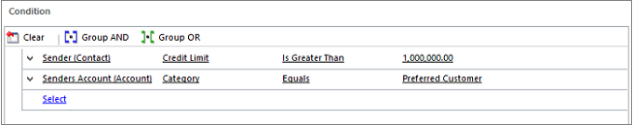

* + In the **Case Properties** section, set the properties for the case. The following example shows how to set the priority of all the automatically created cases to **High**:

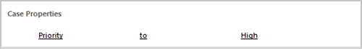

Once a case is created, the incoming email is removed from the queue.

Note

If there’s no routing rule to route the newly created case to another user or queue, the user who’s the owner of the case creation rule will be set as the owner of the case, too.

## https://www.microsoft.com/dynamics/crm/content/images/Help-Expand-Section-Microsoft-CRM.pngActivate or deactivate a case creation rule

Cases are created automatically only when the case creation rule is active. To activate a rule, open it, and on the command bar, click **Activate**.

Once the rule is active, you can’t change it. To change a rule, first open the rule and on the command bar, and click **Deactivate**. You can then edit the rule.

## https://www.microsoft.com/dynamics/crm/content/images/Help-Expand-Section-Microsoft-CRM.pngManage automatic case creation from a queue form

You can create or manage an automatic case creation rule from a queue form, too. To do this, open the queue record, and on the command bar, click **Email to Case Settings**.

**OR:**

**Automatically convert an email to case in crmonline 2015:**

Important: This process should only be carried out by a database administrator or a CRM user with the necessary permissions. Out of the box the Customer Service Manager, System Administrator or System Customizer roles should allocate the required permissions. Server Side Sync / the Email Router should be configured and emails should be arriving in the desired queue within CRM.

